Summary
.
Cleaning data is significant, as it increases the accuracy of the data and thereby the overall productivity. All outdated and improper information leaves you the highest quality when you clean up data.
Figure 6.1
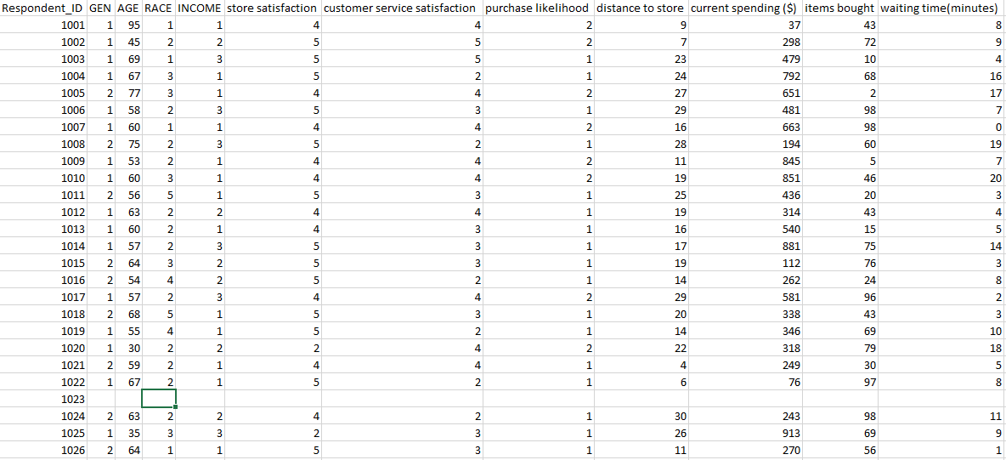
In figure 6.1, we changed the data variables to an easy understandable in order to make the data more understandable. We removed the first columns which consisted to V’s values as it did not have any impact in our data especially when analyzing. We did this by simple cutting and typing the variables.

Figure 6.2
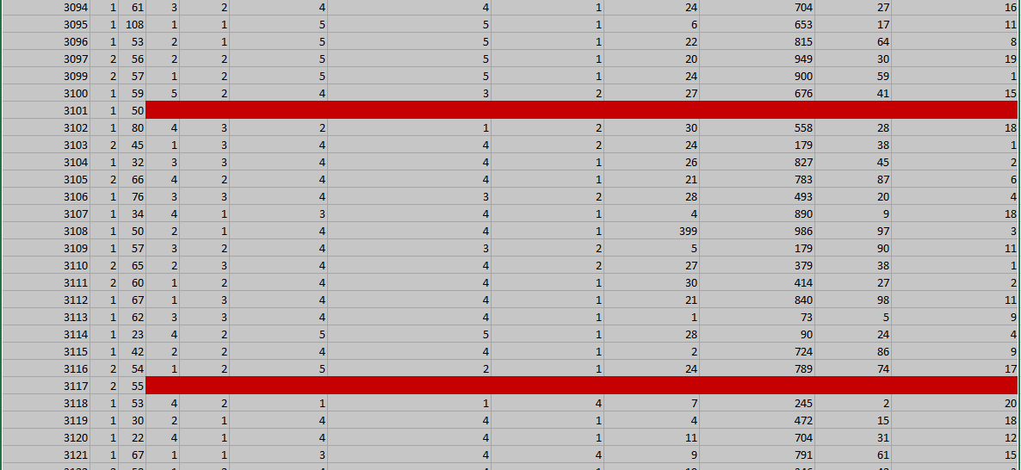
in figure 6.2 we examined the data to see any values that we didn’t consider to when we were doing cleaning. We found that there are blank spaces. Then we highlighted them with red colour. We did this by going to home, find and select then we selected blank space after that we chose a red colour.

Figure 6.3

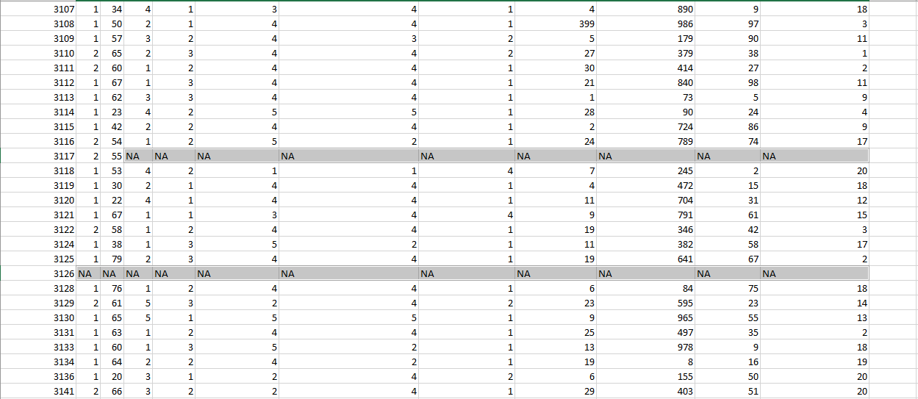
In this figure 6.3 we were finding the missing values and replacing them with a NA meaning data not available. We did that by going to home, find & select, special cases, blanks. After it highlighted all the blank spaces, we wrote NA in one space and pressed CTRL+Enter. This was to display all the missing numbers in every cell in the data.
Figure 6.4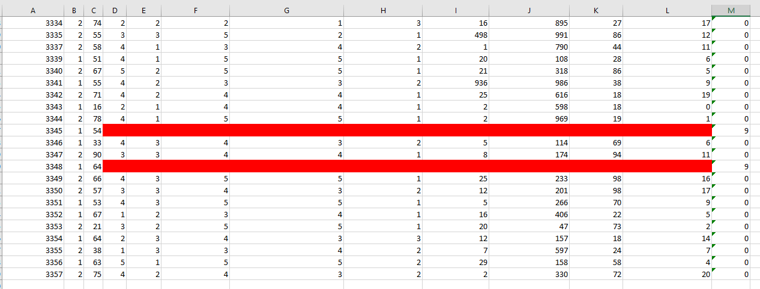
In figure 6.4, we identified every row that has a missing value. This was in order to round cells that had missing numbers to avoid errors during analysis. In this case we use created a columnn and named it COUNTBLANK. Then we use a formula =COUNTBLANK to count all the missing cells in every column so that we can identify the rows that have missing numbers and those that do not have.
Figure 6.5
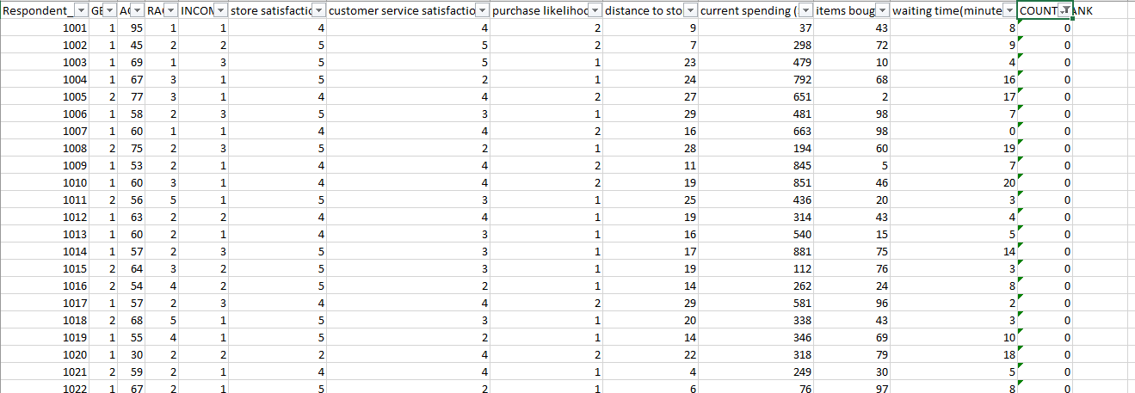
In figure 6.5 filtered the columns that had missing values. This was in order to make the data more meaningfull and to avoid errors when doing analysis. Here we went to excel data then filter and selected 0 only so as to remain with the rows that have no missing numbers only.
Figure 6.6
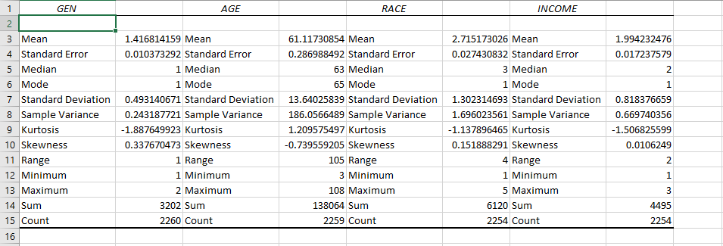
In this case we carried out a summary analysis of gender, age, race and income. We wanted to base our summary to mean, median, mode standard deviation, kurtosis and skewness. In getting the summary statistics we went to Data, data analysis, descriptive statistics. In this case the mean age is 61 is the average age of the people who participated in the study. The is 105 meaning the youngest was 3 years and the oldest was 108.
Figure 6.7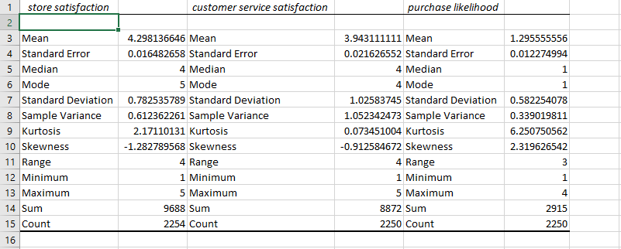
In this we did a summary of store satisactory and customer service satisfactionand purchase likelihood. In the average is 4 in store satisfaction. And 4 stands for satisfied. This shows customers are more satied in store services. In customer service the average response is 3 which is neutral. And in purchase likelihood the average response 1 which stands for highly unlikely.
Figure 6.8
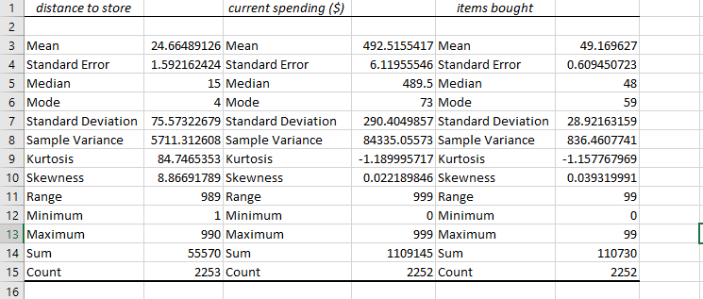
In figure 6.8 we carried a summary statistis on distance to the store, current spending of an individual in the store and the items bought. In this case the average distance travelled to the store is 24 kilometers and the spending on store on average is $492 and average items bought are 49.
Figure 6.9 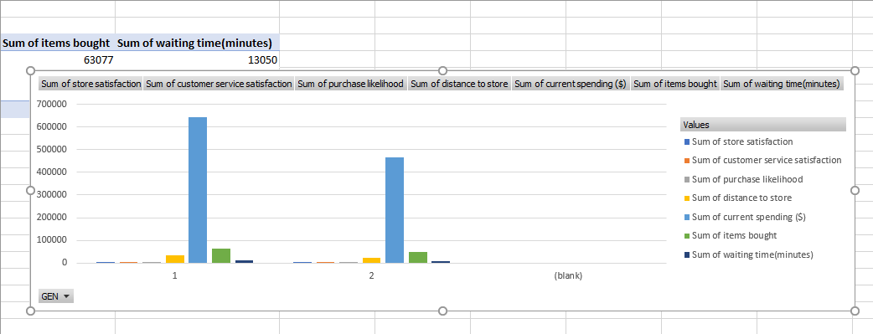
In carrying out complex summary statistics we had to do some table plot to display the summary in form of figures. In figure 6.9 we summaried gender of male and female and showed the summary sum of store satisfaction,customer service satisfaction, purchase likelihood,distance to store, current spending, items bought and waiting time. 1 represent female and 2 represent male. In this case females were more satisfied compared to females in store services, customer servisces and sum of likelihood purchase. Female bought more items than males and even waited more than men.
Figure 6.10
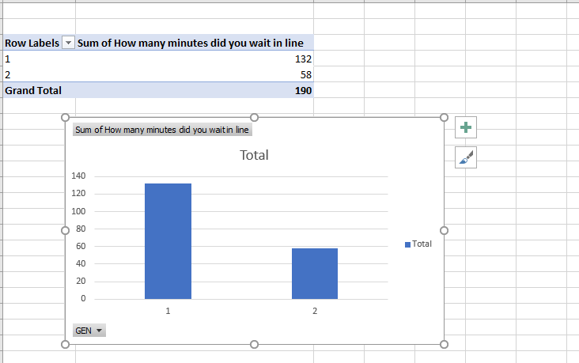
In this we see female wait more compared to males in the line in waiting for services. This shows women are more patient than men.

Figure 6.11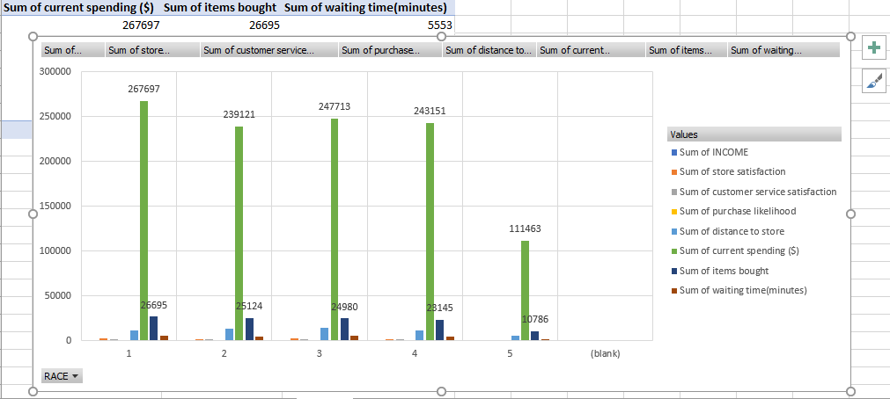
In this figure we see the summary statistics sum of store satisfaction,customer service satisfaction, purchase likelihood,distance to store, current spending, items bought and waiting time of races which are hispanic ,white,black, asian and others respectively. We see that Hispanic have a high spending, are more statisfied ,purchase more, wait more followed by blacks then white then asians and followed by others.
Figure 6.12
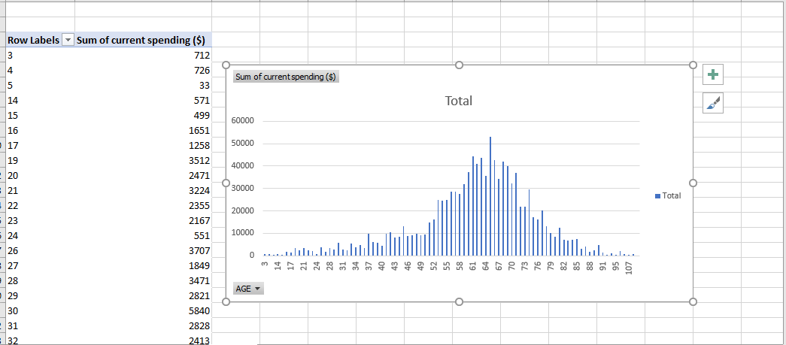
In examing age and the spending on the store. We see there is a normal distribution across the age wher there is low spending on the young age and high spending on the middle age and it reduces to old age.
Figure 6.13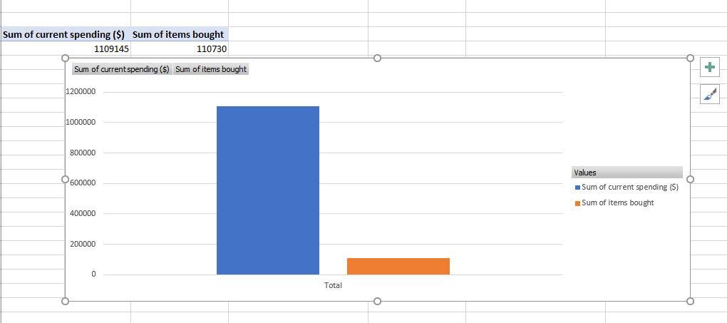
In this case we compare the spending on store items and sum of items bought. Customers spends more more but buy less items from the store.
Figure 6.14
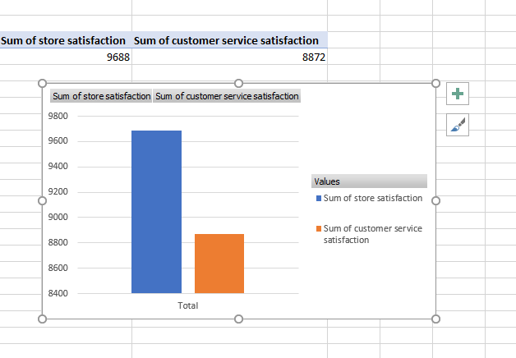
Comparing the satisfaction of store service and customer service satisfaction we see that people are more satisfied in store services compared to customer services.

